The following resources are associated: The dataset ’Birthweight.csv’

Getting started in Jamovi
Jamovi is a free statistical software package which looks similar to SPSS but uses R code to run analysis. The standard version is very simple to use and covers all the basic statistical techniques needed for most research projects. For more advanced users, it allows additional options to be added for more complex analysis and an option for editing the R code.

Downloading Jamovi
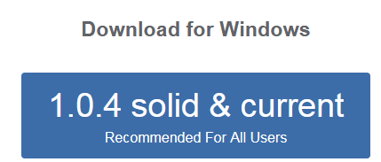
Many Universities now have Jamovi available to staff and students but as it is a free package, Jamovi is simple and quick to install on your home computer as well. Go to the website download page: https://www.jamovi.org/download.html and click on the download box. Once downloaded, it can then be accessed through the ‘Start’ menu.

Standard options in Jamovi
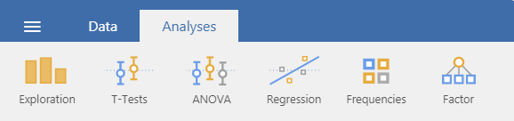
The basic package has only two main tabs; the ‘Data’ tab is where variables are defined and created and the ‘Analysis’ tab clearly shows the range of statistical techniques offered in the basic package.
Open and save files here

Opening data in Jamovi
Jamovi can open a variety of types of data through the ‘Open’ or ‘Import’ menus such as SPSS and csv (comma separated value) files but not Excel. If you are importing your own data set from Excel, reduce the file to have one sheet, ensure that there is only one row of column headers (ideally with short names), make sure that data for each individual is in the same row and save as a csv file.
Download the ‘Birthweight.csv’ file from the Sheffield Hallam Maths and Statistics Support service webpages ‘Practice Datasets’ page through the Resources Stats Helpsheets Practice Datasets page and save it somewhere on your computer.
In Jamovi, select the ‘Open’ option, then select ‘CSV’ from the ‘data files’ menu.
Use the options at the top (arrow or Browse) to locate the saved birthweight.csv file and click on it to open.

Formatting data
The ‘Data’ tab contains the options for formatting and creating variables.
Add or delete variables here
Create new variables using ‘Compute’
Click on ‘Setup’ to label variables and values for categories
Select subsets of the data using ‘Filters’
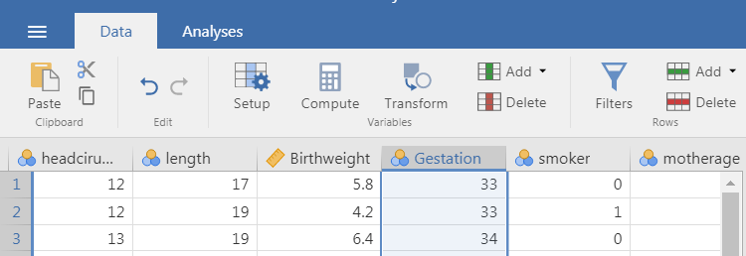
Click on the ‘Setup’ button to start labelling variables and values. Here the details for the variable gestation are shown as this was the highlighted column from the data set. Use the arrows at the side to move to different variables.
Gestation represents the gestational age of the baby in weeks when they are born. This is a continuous variable and the standard length of a pregnancy is 40 weeks. The variable label is currently ‘Gestation’ but can be changed to anything. Type ‘Gestational age (weeks)’ in the Data Variable box. Also select ‘Continuous’ from the listed data types. Then click the right hand arrow to move to the next variable.
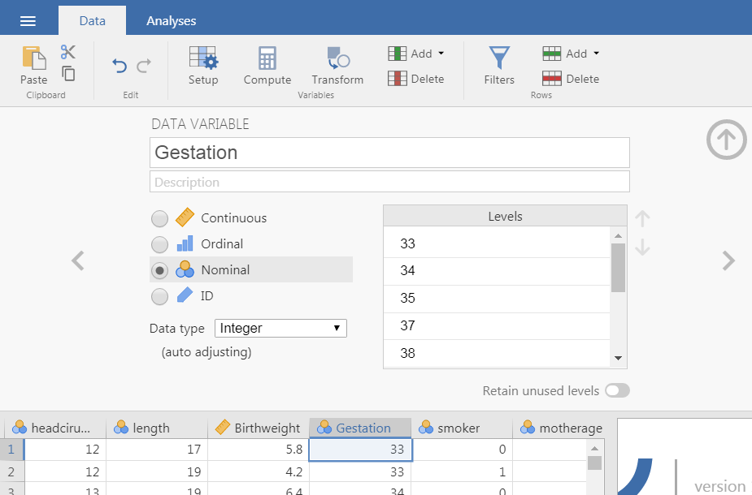
Change the variable name here and this new label will appear on all output
Levels are categories which appear if ‘Nominal’ or ‘Ordinal’ are selected
Select the correct data type here.
Move to the next variable here
Close the set up process here

Specifying value labels
It is generally preferable to record categories as numbers (particularly for ordinal variables) as small typing differences for text are treated as different categories. Labelling these numbers is easy in Jamovi and one really useful aspect of Jamovi is that changes to the labels will be reflected in analysis already run within the file.
Ensure ‘Nominal’ or ‘Ordinal’ is selected for categorical variables so that the ‘Levels’ section is activated. Then type ‘Non-smoker’ over the number 0 and Smoker over the 1. You will see that the dataset now has these values instead of numbers.

The output window
The window to the right of the data is the output window where all requested analysis is displayed. When you save the Jamovi file, this output is also saved along with the options selected for that analysis which is helpful as a reminder of what was carried out. Any changes in the labelling will also update automatically. Here some really basic analysis will be carried out to demonstrate.
To calculate some basic summary statistics to Analyses Exploration Descriptives
Here we will look at whether there are differences in gestational age at birth for smokers and non-smokers. For all types of analysis, the variables of interest are moved from the list on the left hand side to the relevant boxes on the right. Here the continuous variable gestation is moved to the ‘Variables’ box using the arrow and Smoking Status is moved to the ‘Split by’ box.
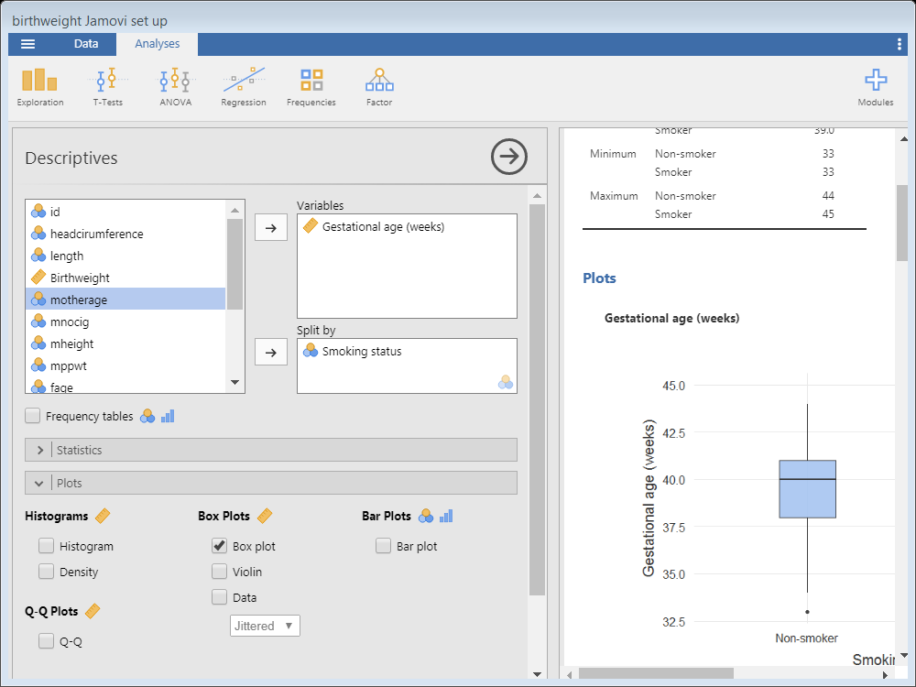
The pull down menus have more options
Output window: Results will update as you select different options.
If changes are made to the data, the output updates
General settings here

Saving and using output
When the dataset is saved, the associated output is also saved. Right click on the output to give a few options for copying or removing output.
The ‘Analysis’ option allows you to copy or remove the output related to the procedure.
The ‘Image’ option will copy just the image selected rather than all the analysis produced during that procedure. Once copied, just paste into Word.

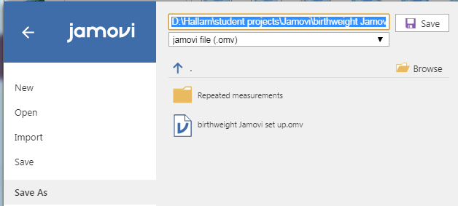
To save the file, go to the top left menu:
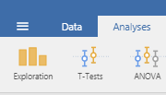

Use ‘Save As’ to save the data and output at the same time.
Give the file a sensible name which will help you find it easily again.

Adding extra analysis
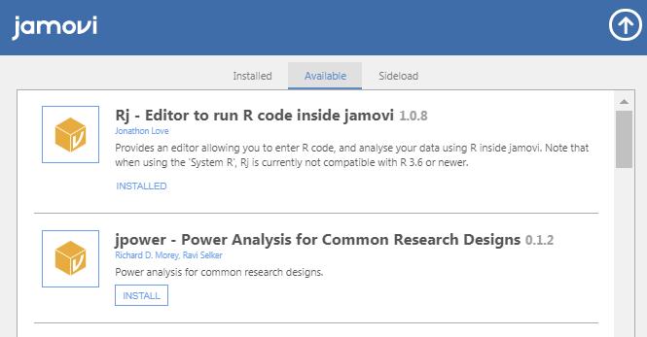
If you have your own version of Jamovi, extra options can be installed through the ‘Modules’ options. Click on the Modules + button on the far right of the analysis tab and select ‘Jamovi library’.

Scroll down the list to choose additional packages of interest and click ‘Install’.
As Jamovi uses R code behind the front end pull down menus, there is an option to edit code directly by installing the Rj – Editor package.

